|  |
| --- |
| http://www.cit.ie/contentfiles/images/Logos/CIT_large/CIT%20MAIN%202012%20(RGB)1.jpg |
| **PROJECT PLAN** |
| Implementing Service Operation and Service Transition |
|  |
|  |
|  |

|  |
| --- |
|  |

**Student Name:** Emmanuela Ogbene

**Lecturer Name:** Noreen Gubbins

**Submittal Date:** March 19th 2015

**VERSION 1.0**

The purpose of this report is to outline how Service Operation and Service Transition processes can be implemented in an organization such as Cork Institute of Technology (**CIT**).

Table of Contents

1. **Introduction …………………………………………………........1 – 1**
2. Purpose of Plan ……………………………………............................1 – 1
3. **Project Background…………………………………………......1 – 1**
4. **Project Benefits………………………………………………......2 – 2**
5. **Project Deliverables…………………………………………....3 – 15**
   1. Service Operation Processes...................................................3 – 6
      1. Event Management..............................................3 – 3
      2. Incident Management.........................................4 – 4
      3. Problem Management.........................................5 – 5
      4. Access Management............................................6 – 6
      5. Request Fulfilment..............................................6 – 6
   2. Service Operation Activities………………………….......................7 – 8
      1. Service Desk…………………………..........................7 – 8
   3. Service Transition Processes…………………………......................9 – 15

4.3.1. Transition Planning and Support...........................9 – 9

4.3.2. Change Management...........................................10 – 10

4.3.3. Service Asset and Configuration Management....11 – 11

4.3.4. Release and Deployment Management...............12 – 12

4.3.5. Service Validation and Testing............................13 – 13

4.3.6. Change Evaluation...............................................14 – 14

4.3.7. Knowledge Management.....................................15 – 15

1. **Project Scope……………………………………………………16 – 16**
2. **Appendix…………………………………………………………17 – 18**
3. **Work Break Down Structure………………………………19 – 20**
4. **Conclusion……………………………………………………….21 – 21**
5. **References……………………………………………………….22 – 22**
6. **Introduction**

# Purpose of Plan

The purpose of this project is to outline how Service Operation and Service Transition processes are implemented in an organisation. A Service Operation is implemented to make sure that IT services are delivered effectively and efficiently. For instance, the service operation process includes fulfilling user requests, fixing problems, resolving service failures, as well as carrying out routine operational tasks. While, a Service Transition is implemented to build and deploy IT services. Service Transition also makes sure that changes to services and Service Management processes are carried out in a coordinated way.

The organisation that I have chosen for this project is **Cork Institute of Technology** (CIT). Cork Institute of Technology, formerly the Regional Technical College, Cork, is an Institute of Technology in Ireland, located in Cork, Ireland opened in 1973.

The Institute has 17,000 students both part-time and full-time in [art](http://en.wikipedia.org/wiki/Art), [business](http://en.wikipedia.org/wiki/Business), [engineering](http://en.wikipedia.org/wiki/Engineering), [music](http://en.wikipedia.org/wiki/Music), [drama](http://en.wikipedia.org/wiki/Drama) and [science](http://en.wikipedia.org/wiki/Science) disciplines. Cork Institute of Technology comprises two constituent Faculties and three constituent Colleges.

The constituent Faculties are Engineering and Science, and Business and Humanities. The constituent colleges are the CIT Crawford College of Art and Design, the CIT Cork School of Music and the National Maritime College of Ireland.

1. **Project Background**

As the new Operations Manager in CIT, my role involves planning, overseeing and having responsibility for all the activities in the organisation which contribute to the effective production of services. Also, it includes understanding the goals of the organisation and developing a clear vision of how operations will help achieve them. This also involves translating these goals into implications for the operation’s performance, objectives, quality, speed, dependability, flexibility and cost. Moreover, due to the numerous decision-making involved with operations, it is critical that as the new operations manager, I have a set of guidelines that are aligned with the organisation’s long term goals. My responsibilities are to design the operation’s services and processes. This design involves determining the physical form, shape and composition of services and processes.

Additionally, as the operation’s manager, deciding what the operations resources should be doing and making sure that it is getting done are activities that are considered. Also, to continually monitor and improve the overall performance of CIT’s operation.

1. **Project Benefits**

The benefits of service transition and service operation processes are as follows:

**Service Transition Processes**

The benefits of Service Transition include:

* Estimating the costs, timing, resources, and risks associated with a service.
* Diminishing delays and downtimes due to services and Changes being analysed in a test environment.
* Easier to follow processes and procedures.
* Verifying that new or changed services are maintainable and cost-effective.
* Improved confidence that the new or changed service will meet needs and expectations without affecting other services or stakeholders.
* Deploying Changes more successfully.

**Service Operation Processes**

The benefits of Service Operation include:

* Reducing unplanned resource and costs through better handling of service outages and identification of their root causes.
* Enabling the organisation and customers to add value from the services they are receiving by reducing downtime.
* Enabling continual improvement and better investment decision making by providing operational results and data for decision support.
* Enabling users to improve their productivity or the quality of business services by providing quick and effective access to standard services.
* Meeting the objectives of the organization’s security policy by ensuring that IT services will only be accessed by those authorized to use them.

1. **Project Deliverables**

# Service Operation Processes

The purpose of Service Operation is to coordinate and carry out the activities and processes required to deliver and manage services at agreed levels to business users and customers. Also, it is responsible for the ongoing management of the technology that is used to deliver and support services.

Service Operation is implemented in order to maintain organisation satisfaction and confidence in IT through effective and efficient delivery and support of agreed IT services.

It also minimizes the impact of service outages on day-to-day business activities.

Moreover, it ensures that access to agreed IT services is only provided to those authorized to receive those services.

Service operation is also the only phase within the service lifecycle that has functions defined within it. There are four such functions: service desk, technical management, application management and IT operations management. While these functions actively support the other phases of the lifecycle, they reside within service operation.

* + 1. **Event Management Process**

Firstly, an event can be defined as any detectable or discernable occurrence that has significance for the management of the IT infrastructure or the delivery of IT service, and evaluation of the impact a deviation might cause to the service.

Event Management is the process responsible for managing events throughout their lifecycle. Event management is one of the main activities of IT operations. The purpose of event management is to manage events throughout their lifecycle, from detection through to determining the appropriate control action.

Events may be detected by a configuration item (CI) itself, or by a management tool polling the CI. Any event detected may lead to an action being taken; the event could be acknowledged, may trigger an action or may lead to an incident, problem or change record being created. Responses to events may be automated or may require manual intervention.

* + 1. **Incident Management Process**

An incident is defined as an unplanned interruption to an IT service, a reduction in the quality of an IT service, or a failure of a CI (configuration item) that has not yet impacted an IT service.

Incident Management is responsible for progress of all incidents from reporting to closing – usually the responsibility of service desk.

The purpose of incident management is to restore normal service as quickly as possible and to minimize the adverse impact on business operations. ‘Normal’ service is the level of service agreed and defined within the SLAs and OLAs.

Incident Management Process is implemented to:

* Make sure that standardized procedures and methods are used for prompt and efficient response, documentation, analysis, reporting of incidents and ongoing management.
* Communication and visibility of incidents are improved.
* Improve organisation perception of IT with the help of a professional approach so that incidents will be resolved and reported quickly.
* Align incident management activities and priorities with those of the business.
* Maintain both student and staff satisfaction without losing the quality of IT services.

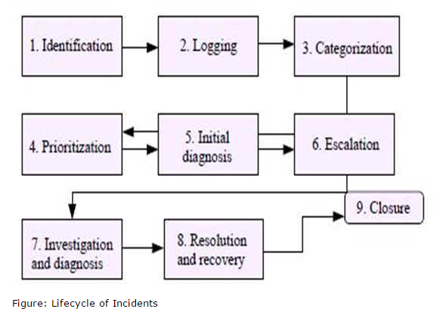

* + 1. **Problem Management Process**

A problem is defined as an underlying cause of one or more incidents. The cause is not usually known at the time a problem record is created, and the problem management process is responsible for further investigation.

The purpose of problem management is to manage the lifecycle of all problems, from first identification through investigation and documentation to eventual removal. Problem management seeks to minimize the adverse impacts of incidents and problems and to proactively prevent any recurrence of such incidents. Ultimately, it is about seeking the root cause of incidents and problems and initiating actions to rectify or improve the situation.

The goal of Problem Management process is to prevent problems and resulting incidents from happening. Also, it includes eliminating recurring incidents and minimizing the impact of incidents that cannot be prevented.

**The Life Cycle of Problem Management is as follows:**

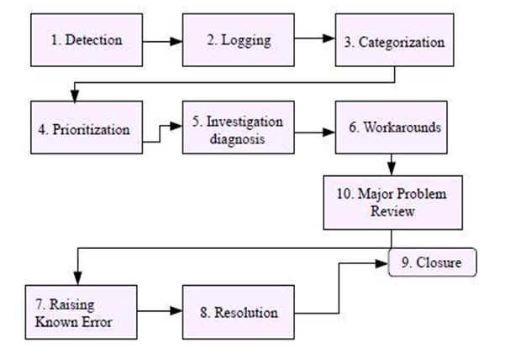

* + 1. **Access Management Process**

Access management is the process of granting authorized users the right to use a service, while preventing access to non-authorized users. It is, therefore, the execution of policies and actions defined in information security and availability management.

The purpose of the Access Management process is to provide the rights for both students and staff to be able to access a service or group of services in CIT, while preventing access to non-authorized students or staff.

Access Management helps to manage confidentiality, availability and integrity of data and intellectual property. It is the userfacing process that underpins information security management. Access management is concerned with identity (unique information that distinguishes an individual) and rights (settings that provide access to data and services). The process includes verifying identity and entitlement, granting access to services, logging and tracking access and removing or modifying rights when status or roles change.

* + 1. **Request Fulfillment Process**

A Service Request is a formal request from a user (i.e. either a student or a staff) in CIT for something to be provided.

Request Fulfillment Management is the process responsible for managing the lifecycle of all service requests received from the users.

The purpose of request fulfilment is to enable students and staff to request and receive standard services, to source and deliver these services, to provide information to students and staff about services, and to assist with general information, complaints and comments.

Their scale and frequent low-risk nature requires this separate process rather than potentially congesting the normal incident and change management processes. Moreover, all requests are logged and tracked, usually via the service desk, and may necessitate an appropriate level of authorization before fulfilment.

# Service Operation Activities

* + 1. **Service Desk**

The main objective of the Service Desk is to serve as a point of contact between CIT Students and Staff, and IT Services Management.

In other words, the service desk provides a single point of contact for all users of IT. The service desk usually logs and manages all incidents, service requests and access requests and provides a user interface for all other service operation processes and activities. The service desk is the ‘shop window’ to IT for users; it is where the vast majority of users get their first impression of the IT service provider.

Some of the specific service desk responsibilities include:

* Logging, escalating and closing incidents.
* Logging requests and answering questions.
* Keeping users informed of the status of services, incidents and requests.
* Managing the lifecycle of incidents and requests, escalating as appropriate and closing them when the user is satisfied.

In addition, there are many ways of structuring and organizing service desks. These include the use (or combination of) four types namely:

* **Local service desk** – This is physically close to the users.
* **Centralized service desk** – This is one physical location.

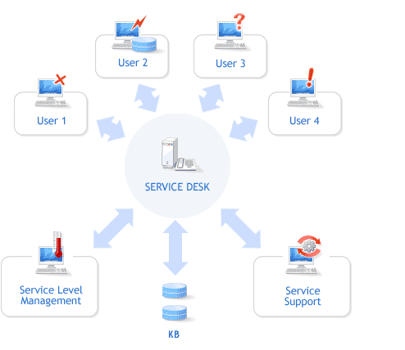

* **Virtual service desk** – Staff are in many locations but appear to the users to be a single team.

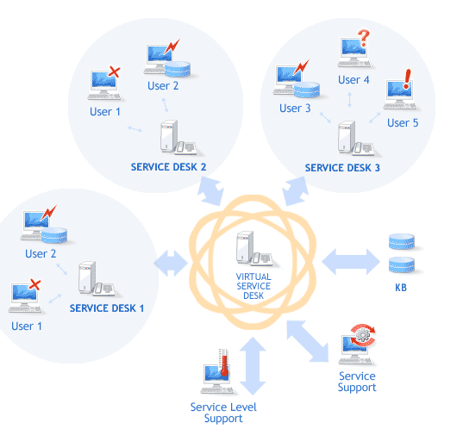

* **Follow-the-sun** – This is service desks in different time zones which, gives 24-hour coverage by passing calls to a location where staff are working.

In conclusion, Virtual and follow-the-sun service desks are best for the chosen organisation: CIT as they rely on technology to enable the routing of calls, mails and requests to enable the successful running of those types of desk.

# Service Transition Processes

Service Transition is the phase where new or changed services are transitioned into Service Operations while controlling the risks of service failure and business disruption. In other words, it makes sure that new or changed service satisfies the needs of students and staff, and the organisation expectations as documented in the service strategy and service design lifecycle stages. Activities performed within this phase include:

* Planning and managing the capacity and resources needed to package, build, test, and deploy a release into production.
* Evaluating the service capability and risk profile prior to release.
* Creating repeatable build and installation mechanisms that can be used to deploy releases into test and production environments.
* Ensuring that services can be managed operated and supported in accordance with requirements established in Service Design.
  + 1. **Transition Planning and Support**

Transition Planning and Support also known as ITIL Project Management aims to plan and coordinate the resources to deploy a major Release within the predicted cost, time and quality estimates. Therefore, an effective transition planning and support can significantly improve a service provider’s ability to handle high volumes of change and releases across its customer base. This has two main areas of activity:

* Planning and coordinating the resources and capabilities needed to enable the smooth operation of the service transition stage.
* Planning and coordinating individual service transitions, to ensure that they deliver the expected business benefits.

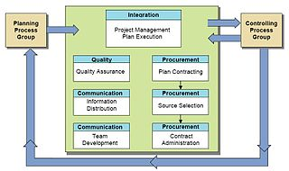

* + 1. **Change Management**

Change Management ensures that standardized methods and procedures are used to manage all changes to the services or production environments. This process also ensures that all changes to service management processes, service assets, and configuration items are recorded in the Configuration Management System. All changes are done in accordance with established service policies and procedures that minimize risk to the chosen organisation. During this process a service provider assesses and evaluates the risks associated with a change and develops a contingency plan to follow if implementing the change yields an unexpected result.

The aim of Change Management is to evaluate and plan the change process to ensure that, if a change is made, it is done in the most efficient way possible, following the established procedures and ensuring the quality and continuity of the IT service at all times.

**The Change Process**

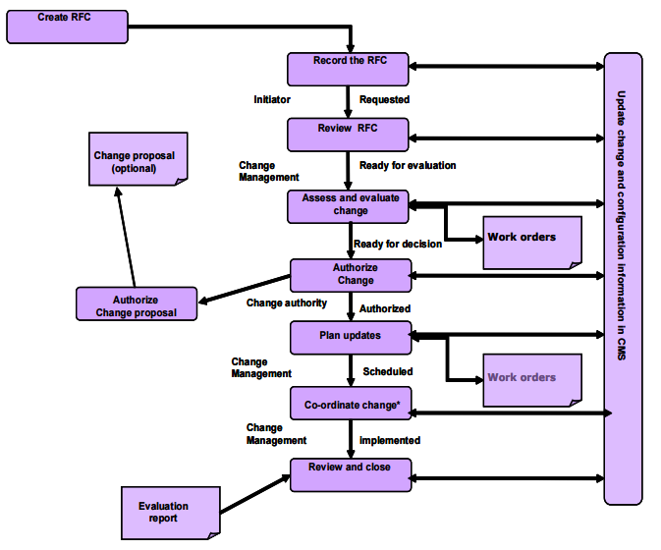

* + 1. **Service Asset and Configuration Management**

Service Asset and Configuration Management (**SACM**) is of both Asset Management and Configuration Management. During Asset Management, the service provider tracks and reports the value and ownership of financial assets throughout their service life.

Configuration Management tracks, using a CMDB (Configuration Management Database), the Configuration Items (CIs) of an IT System. Configuration Items are the organizational elements that are used in the provision and management of IT services. The CMDB contains information that relates to CI maintenance, CI movements, and problems associated with CIs. Additional items such as software, hardware, documentation and personnel that the IT Services are dependent on are also tracked in the CMDB.

Furthermore, implementing this process ensures the integrity of service assets and configurations in order to support the effective and efficient management of the IT organisation. The main reason for configuration management in the chosen organisation is to gather the information needed (in a non-duplicated manner) about the IT components and how they relate to each other. The reason for this is to ensure that the relevant information is available for all the other processes to ensure that detailed impact and risk analysis can take place.

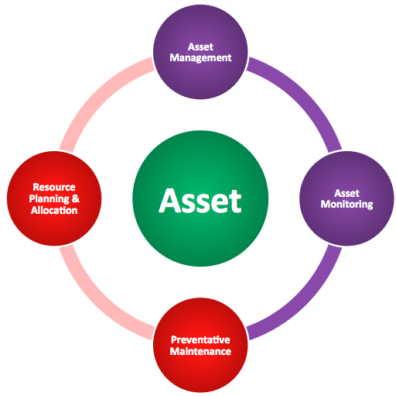

* + 1. **Release and Deployment Management**

Release and Deployment management is a process responsible for planning, scheduling and controlling the build, test and deployment of releases, and for delivering new functionality required by the business while protecting the integrity of existing services.

In the Release and Deployment management process different considerations apply in respect of the way in which the release is deployed. The most frequently occurring options for the rollout of releases are: “big bang” versus phased, “push and pull”, automated or manual.

However, effective release and deployment will deliver significant business value in the chosen organisation by delivering changes at optimized speed, risk and cost, and offering a consistent, appropriate and auditable implementation of usable and useful services. Release and deployment management covers the whole build, test and implementation of new or changed services, from planning through to early life support.

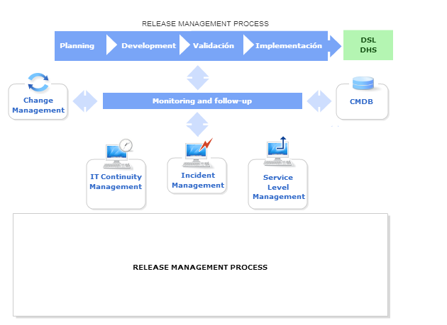

* + 1. **Service Validation and Testing**

The service validation and testing process is implemented to ensure that new or changed IT service matches its design specification and will meet the needs of the organisation.

Service validation and testing provides confidence that the release will deliver the expected outcomes and value for students and staff, within the projected costs, capacity and constraints. The service is tested explicitly against the utilities and warranties set out in the service design package to ensure that it will be both fit for purpose and fit for use. This includes testing of functionality, availability, continuity, capacity, security and usability. Testing also ensures that the service can be operated and managed by the service provider.

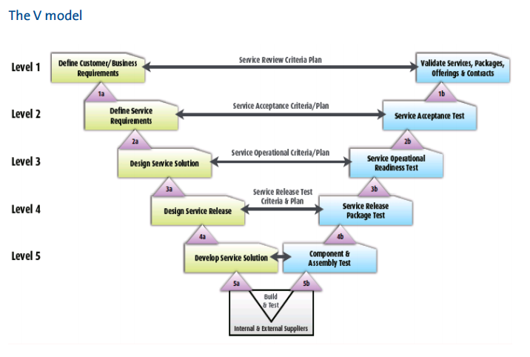

* + 1. **Change Evaluation**

The purpose of the change evaluation process is to provide a formal, standardized means of determining the performance of a service change in the context of likely impacts on business outcomes, and on existing and proposed services and IT infrastructure.

Change evaluation assesses the actual performance of a change against its predicted performance, and identifies risks and issues related to the change. Change evaluation is closely linked to change management. The main output of change evaluation is an evaluation report which is used to help change management personnel decide whether to authorize a change. Formal change evaluation is not required for all changes, and each service provider defines when this formal process should be used and when the evaluation can be carried out as part of change management.

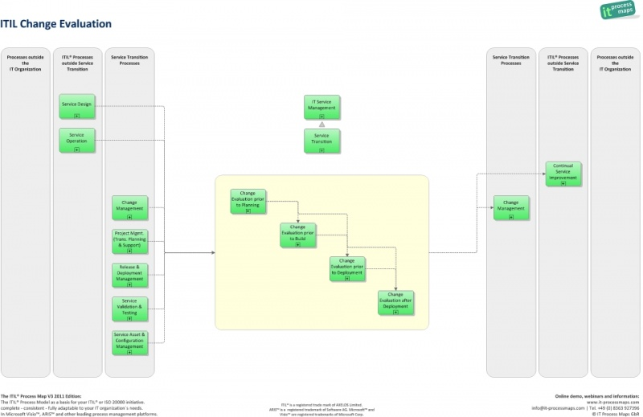

* + 1. **Knowledge Management**

This is the process used to collect, analyse, and exchange information and knowledge within the organisation. A key component of this process is the Service Knowledge Management System (SKMS). The SKMS stores the information and knowledge and allows it to be shared among the IT organisation, its partners, and customers.

The goal of knowledge management is to enable the organisation to improve the quality of management decision-making by ensuring that reliable and secure information and data is available throughout the service lifecycle. An example of this knowledge in the service transition phase may include:

* Identity of stakeholders.
* Acceptable risk levels and performance expectations.
* Available resource and timescales.

Some examples where successful transition rests on appropriate knowledge management include:

* User, service desk, support staff and supplier understanding of the new or changed service, including knowledge of errors signed off before deployment, to facilitate their roles within that service.
* Awareness of the use of the service, and the discontinuation of previous versions.
* Establishment of the acceptable risk and confidence levels associated with the transition, e.g. measuring, understanding and acting correctly on results of testing and other assurance results.

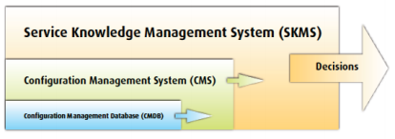

|  |
| --- |
|  |
|  |
|  |
|  |
|  |

1. **Project Scope**

This project plan will introduce the main objectives of the Service Operation and Service Transition Processes. The project plan will outline the implementation of the Service Operation and Service Transition Processes in an organization such as CIT.

Here, the scopes of these ITIL service lifecycles are emphasized in detail:

The scope of the Service Operation is to provide the ongoing management and execution of the many service management processes that are performed in service operation (which is service management processes). To provide the management of the infrastructure used to deliver services (i.e. The Technology). And, to provide the people who drive the demand for the organization’s services and the people who decides how this will be done.

While, the scope of the Service Transition is to provide guidance for the development and improvement of capabilities for transitioning new and changed services in CIT into supported environments, including release planning, building, testing, evaluation and deployment. It considers service retirement, transfer of services between service providers. Moreover, it focuses on how to ensure that the requirements from service strategy, developed in service design, are effectively realized in service operation while controlling the risks of failure and subsequent disruption. And, it includes the transition of changes in the service provider’s service management capabilities that will impact on the ways of working, the organization, people, projects and third parties involved in service management.

Also, the scope is to clearly understand the processes that can be implemented in CIT, and their goals and objectives in order to deliver effective services. To fulfil these objectives, it is necessary that the new or changed services are aligned with the organisational requirements and organisational operations.

1. **Appendix**

Appendix A: Summary of the main processes involved in Service Operation.

**Appendix A:**

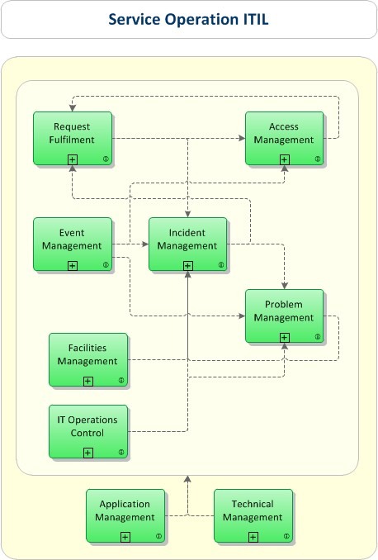

Appendix B: Summary of the main processes involved in Service Transition.

**Appendix B:**

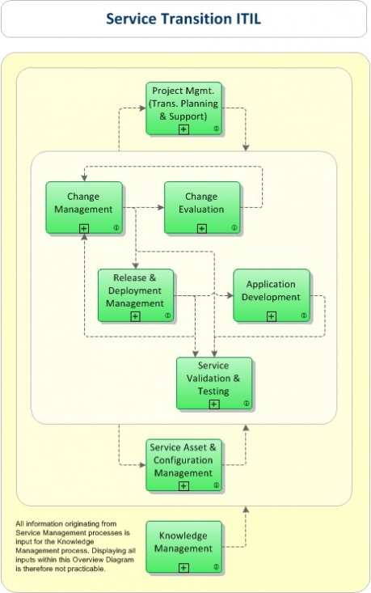

1. **Work Break Down Structure**

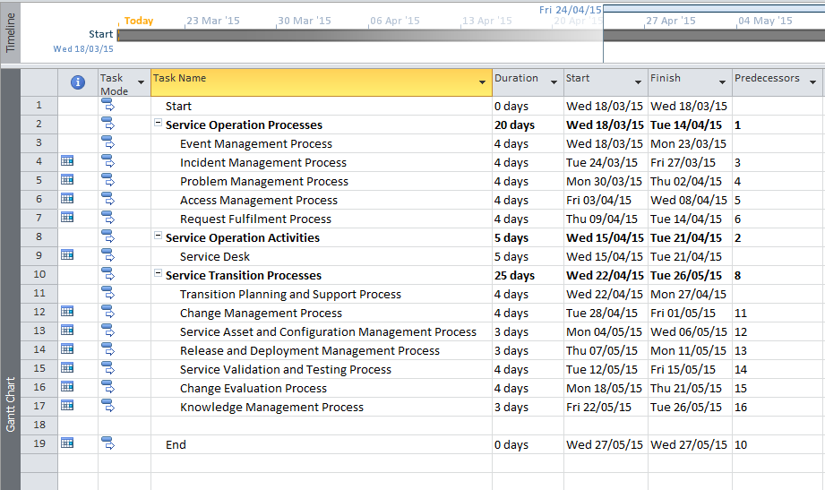

**Plan – Gantt chart**

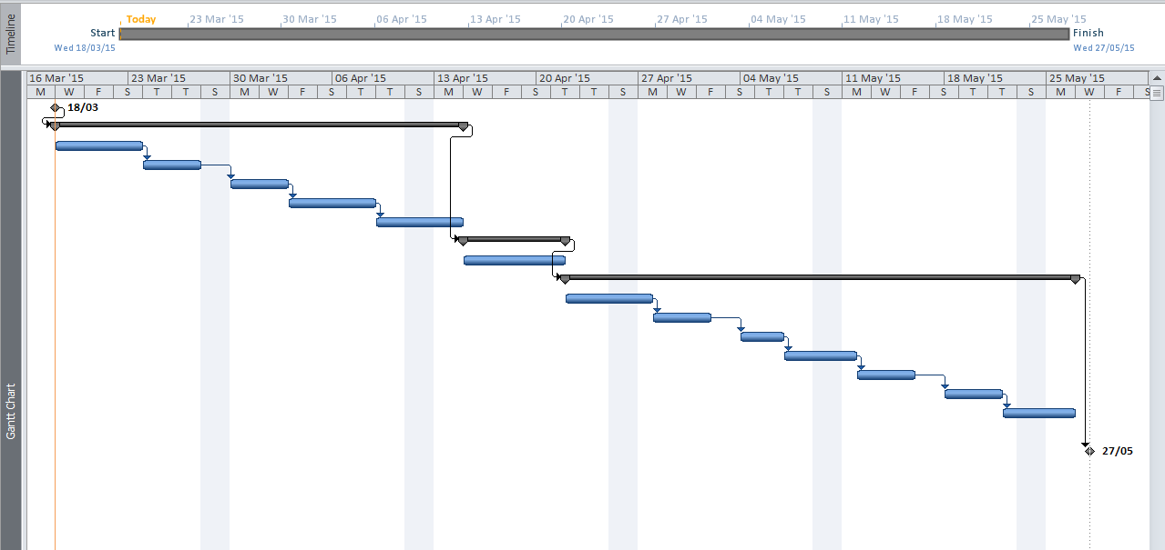

1. **Conclusion**

In conclusion, implementing Service Operation and Service Transition Processes will be beneficial for CIT as service transition creates value for the organisation by improving:

* The ability to adapt quickly to new requirements.
* The predictions of service levels and warranties for new and changed services.
* The success rate of changes and releases for the organisation.
* Clarity of plans so the business can link their organisation change plans to transition plans.
* Confidence in the degree of compliance with the organisation requirements during change.

While, the service operation creates value for the organisation by:

* Ensuring that services are operated within expected performance parameters.
* Restoring services quickly in the event of service interruption.
* Minimizing impact to the organisation in the event of service interruption.
* Providing a focal point for communication between students and staff, and the Service Provider organization.

1. **References**

Anon, (2015) [**online**], available: <http://www.best-management-practice.com/gempdf/itsmf_an_introductory_overview_of_itil_v3.pdf> [accessed:17/ 03/2015]

Anon, (2015) [**online**], available: <http://www.itservicemanagement-itil.com/wp-content/downloads/ITIL-V3-Application-Support.pdf> [accessed: 12/03/2015].

Itil.osiatis.es, (2015) “Service Level Management - Introduction and Objectives - Basic Concepts.” [**online**], available: <http://itil.osiatis.es/ITIL_course/it_service_management/service_level_management/introduction_and_objectives_service_level_management/basic_concepts_service_level_management.php> [accessed: 17/03/2015].

Stayahead.com, (2015) “StayAhead ITIL® Service Transition & Service Operation Combined Training Course :: ITIL® Service Transition & Service Operation Combined Course.” [**online**], available: <http://www.stayahead.com/Training-Courses/information-technology-infrastructure-library-itil-prince-training-courses/ITIL-Service-Transition-Service-Operation-Combined-Outline--IVSTSOC.html> [accessed: 14/03/ 2015].

Toolkit.smallbiz.nsw.gov.au, (2015) “Role of the Operations Manager.” [**online**], available: <http://toolkit.smallbiz.nsw.gov.au/part/13/63/260> [accessed: 17/03/ 2015].

Tutorialsweb.com, (2015) “ITIL Foundation Certification Notes.” [**online**], available: <http://www.tutorialsweb.com/CertNotes/ITIL-cert/itil-foundation-12.htm> [accessed: 12/03/2015].

Ucisa.ac.uk, (2015) [**online**], available: <https://www.ucisa.ac.uk/~/media/Files/members/activities/ITIL/servicetransition/ITIL_introducing%20service%20transition%20pdf.ashx> [accessed: 17/03/2015].